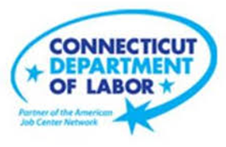

**NEW WEEKLY JOB POSTINGS FROM   
HELP WANTED ONLINE  
Office of Research**

**Week Ending May 7th, 2022: Weekly New Ads Reach Highest Level on Record**WETHERSFIELD, May 13th, 2022 – During the week ending May 7th, there were 12,838 new postings, up 3,282 new ads or +34% over the week. This is the second highest one-week increase this year, the largest being the +3,695 or +44.9% increase during the week ending March 5th. The largest industry increase occurred in Transportation & Warehousing, up 718 to 902 new ads. Most of that industry change is due to a 661 new job ad increase for the Heavy & Tractor-Trailer Truck Drivers, which had 739 new ads, up from 78 a week ago. That occupation represents 23% of the total new ad increase for the week. Employers with the largest increases include Capital One (+122 new ads), Travelers (+92 new ads) and Great Clips (+88 new ads). The table below shows that both the United States and Connecticut had large over the week increases. This current statewide level is the highest on record and 52% higher than weekly levels from a year ago.  
  
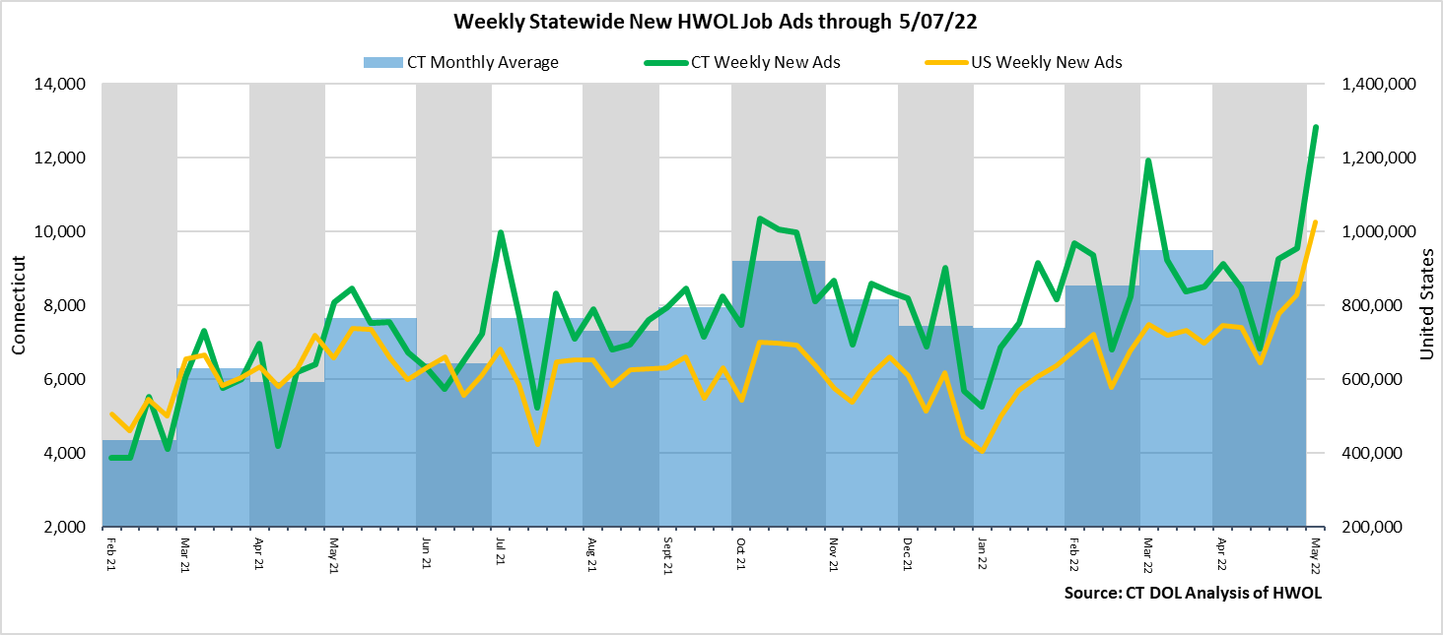  
**Industries** with the most new postings include Health Care & Social Assistance, Finance & Insurance, and   
Retail Trade.

**Occupations** with the most new postings include Heavy and Tractor Trailer Truck Drivers, Registered Nurses, and Retail Salespersons.

**Employers** with the most new postings include Capital One, Travelers, and UnitedHeath Group.

**The three industries with the most new job postings were:**

* **Health Care & Social Assistance** (2,080 new postings, +26% over the week)
* **Finance & Insurance** (1,409 new postings, +24% over the week)
* **Retail Trade** (1,115 new postings, +60% over the week)

   
 During the week ending May 7th, the total ad increase of 3,282 new ads or 34% is the net result of change within 16 increasing, one unchanged, and 4 decreasing industries. Among increasing industries, 9 were up 100 or more over the week and four had increases of 300 or more. The largest over the week increases occurred in Transportation & Warehousing (+718 new ads), Health Care & Social Asst. (+425 new ads), Retail Trade (+416 new ads), and Accom. & Food Services (+300 new ads). These four industries accounted for 56 percent of the total over the week increase. The employers with the most ads in those four industries respectively were United Parcel Service (96 new ads), Hartford Healthcare (93 new ads), Walmart/Sam’s Club (114 new ads), and Panera Bread (72 new ads). The four decreasing industries fell by a combined 189 new ads. Manufacturing had the largest over the week decline, down 113 new ads.  
  
  
 For more information on total job ads by industry for Connecticut and its labor market areas, see the monthly report available here: <https://www1.ctdol.state.ct.us/lmi/hwol.asp>

**New Job Postings by Occupation** 

**The occupations with the most new postings were:**

* Heavy and Tractor-Trailer Truck Drivers (739 new postings, +847% over the week)
* Registered Nurses (429 new postings, -16% over the week)
* Retail Salespersons (300 new ads, +36% over the week)

**Employers with the Most New Job Postings**

Employers with the most new job postings during the week were mostly in Finance & Insurance, Healthcare, and Retail Trade. The 25 employers shown above account for 20 percent of all new ads. Among the top 25 employers, 21 had over the week ad increases and 4 had decreases. The largest top 25 employer increase over the week was Capital One (+122 new ads) and the largest decreasing employer was Yale-New Haven Health System (-77 new ads). Over four weeks, 24 of 25 employers shown above had increases, the largest being Travelers (+159 new ads), Great Clips (+91 new ads), and United Parcel Service (+89 new ads).

**What is HWOL?**The **Conference Board Help Wanted Online**® Data Series (HWOL) measures the number of new, first-time Online job postings and jobs reposted from the previous month for over 16,000 Internet job boards, corporate boards and smaller job sites that serve niche markets and smaller geographic areas. To view more HWOL data, go to: <https://www1.ctdol.state.ct.us/lmi/hwol.asp>